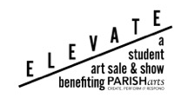
2018 Elevate the Arts Event
Thursday, May 10, 2018
6:00 p.m. Jonsson Art Gallery
Presented by The Arts People

SPONSORSHIP LEVELS
$500
Eight Tickets to the Event
Name Recognition on Marketing Materials
Early Access to Event
Autographed Commemorative Poster

$250
Six Tickets to the Event
Name Recognition on Marketing Materials
Autographed Commemorative Poster

$100
Four Tickets to the Event
Name Recognition on Marketing Materials

$50
Two Tickets to the Event

$10
Admission for One Person

DONOR NAME:
(Please print name as it should appear in any written materials. Please circle alphabetizing letter.)
CONTACT PERSON’S NAME:
ADDRESS/CITY/STATE/ZIP:
PHONE: _______________________________________ EMAIL:
DONOR SIGNATURE: DATE:
PAYMENT: Credit Card______ Check________
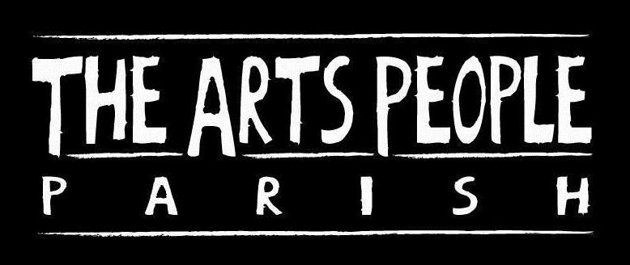
***Contract must be received by May 1, 2018 to be listed as a sponsor in the marketing materials.*

